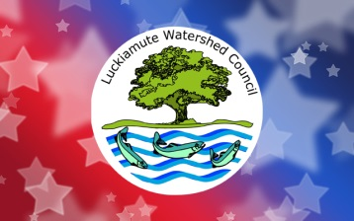
July 4th Grand Parade Volunteer Interest Form

Be a Grand Parade Volunteer! Help keep trash out of our waterways by volunteering to be a part of the “rear detachment” during the annual Monmouth-Independence Rotary Club Grand Parade. Your mission will include riding or walking beside our truck as part of the Fourth of July parade, holding up signs, and helping to collect trash along the parade route. Don’t miss this unique opportunity to keep our waterways clean and interact with the cheering public as part of a well-loved Fourth of July tradition!
Details
The Rotary Club Grand Parade is approximately 3.3 miles long, beginning at Western Oregon University in Monmouth and traveling through Monmouth and Independence on Main and Monmouth Streets to Riverview Park where it ends. We’ve broken up the 3-mile route into three shorter sections. Volunteers can sign up to join in for just one or two segments, or the whole parade route.
Name: ___________________________________________________________________________________
Mailing Address: ___________________________________________________________________________________
City: ___________________________________________ State: _______ Zip: _______________
Home Phone: ______________________________ Cell Phone: ________________________________
Email: _____________________________________________________________________________________
Which parade segment(s) would you like to join us for?
☐ Western Oregon University to Monmouth Burgerville (approximately 1 mile)
☐ Monmouth Burgerville to Roth’s parking lot (approximately 1.2 miles)
☐ Roth’s parking lot to Riverview Park (approximately 1.2 miles)
Join our mailing list? ☐Yes ☐No

