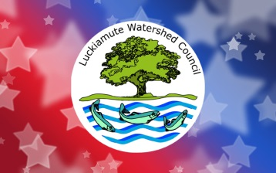
July 4th Grand Parade Volunteer Interest Form

Be a Grand Parade Volunteer! Help keep trash out of our waterways by volunteering to be a part of the “rear detachment” during the annual Monmouth-Independence Rotary Club Grand Parade. Your mission will include riding or walking beside our truck as part of the Fourth of July parade, holding up signs, and helping to collect trash along the parade route. Don’t miss this unique opportunity to keep our waterways clean and interact with the cheering public as part of a well-loved Fourth of July tradition!
Details
The Rotary Club Grand Parade is approximately 3.3 miles long, beginning at Western Oregon University in Monmouth and traveling through Monmouth and Independence on Main and Monmouth Streets to Riverview Park where it ends. Volunteers can sign up to join in for the whole parade route, or for smaller sections of the route.
Name: ___________________________________________________________________________________
Home Phone: ______________________________ Cell Phone: ________________________________
Email: ____________________________________________________________________________________
Yes, I would like to be a part of the parade! I can join the LWC for:
☐ The whole route (from Western Oregon University to Riverview Park – 3.3 miles)
☐ Part of the route
☐ Not sure yet
Join our mailing list? ☐Yes ☐No

